This document will describe how to configure your Jumbo Hostspot for Local South Africa DMR.

- Give your Hotspot some power 2A 5V USB cable.
- Waite about 5 Minutes and then scan for local wifi.
- You should see a Wifi called Pi-Start-Setup

- Connect to this wif and use the password raspberry.
- Enter password raspberry
- Then connect to Jumbo Hostspot Administration page by using your web browser going to the following address. http://192.168.50.1/

You should then see a screen like this one.
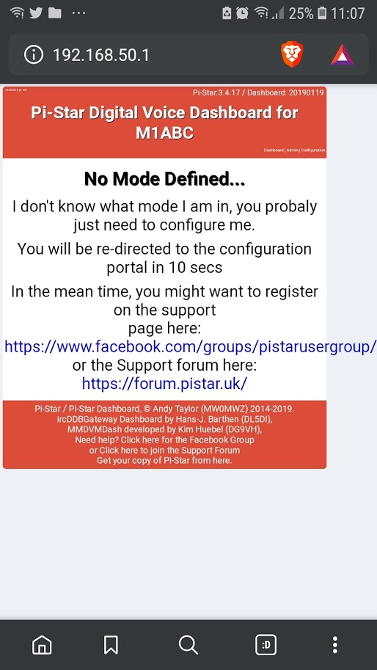

After this screen you will see the next screen after 10 seconds.

If you get to the Dashboard screen then click on the Configure menu
If you get asked for a user name and password enter the following.
pi-start and raspberry

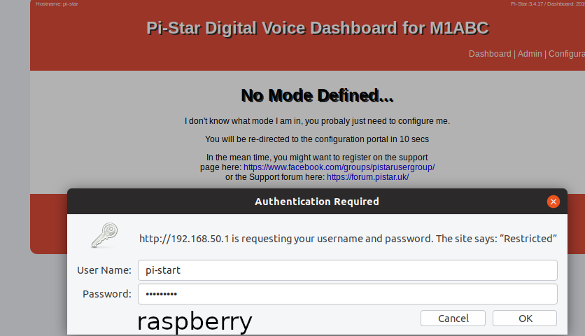
You should the get the following configuration screen.
- Make all the changes as in the green highlighted sections to correspond to your station taking note on some DMR id’s there is an additional 01
- Press the apply change button at every section before moving to the next section.

Goto https://brandmeister.network/?page=selfcare
And register your Jumbospot and give it a password. Then enter the password under Hotspot Security
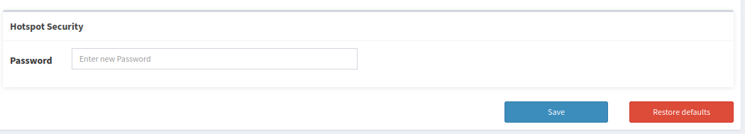

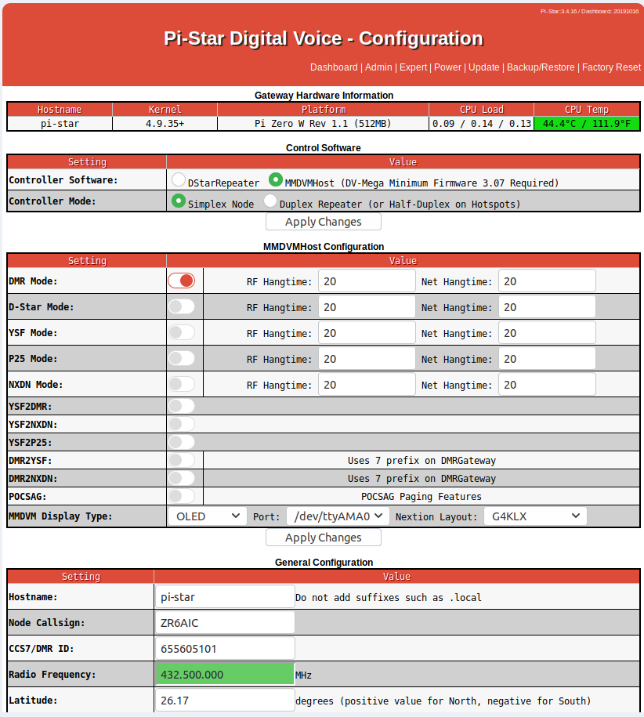

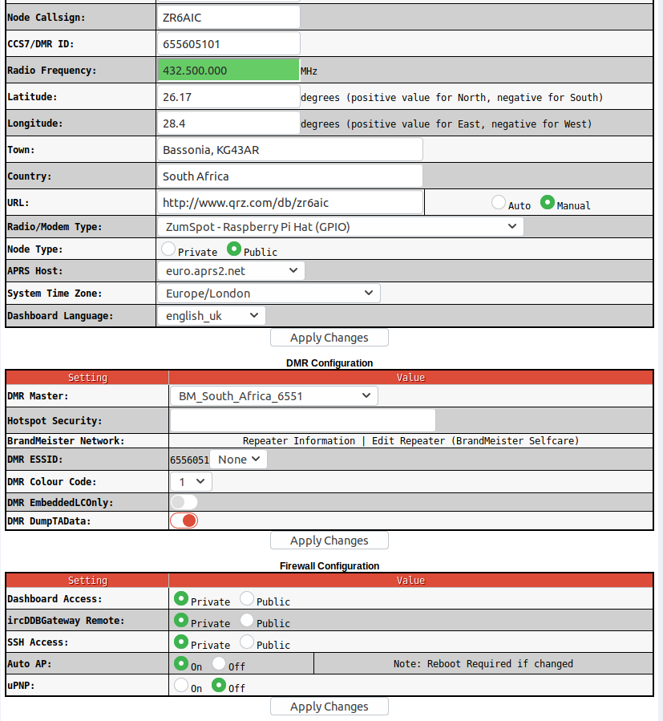

Click on the Configure Wifi section and a new pop screen will apear.

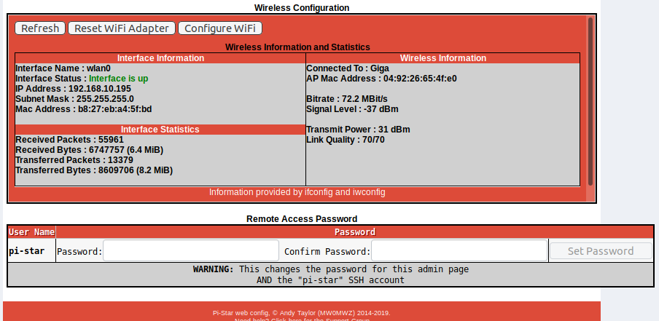

Enter your Wifi routers ID and Password in the popup as seen below.

You can enter multiple routers if you sometimes use different router work than at home.
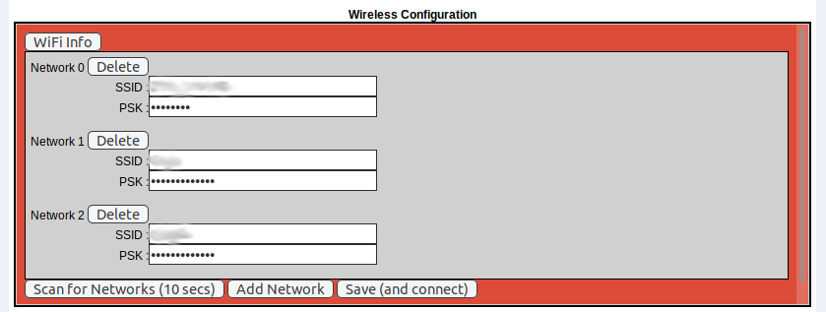

You now mite loose connectivity. If you don’t loose connectivity you need to reboot your Jumbo spot so that the new settings take affect.

By clicking on the power button at the top you can now shut-down your Jumbo Spot.
Then switch the power off and on again.

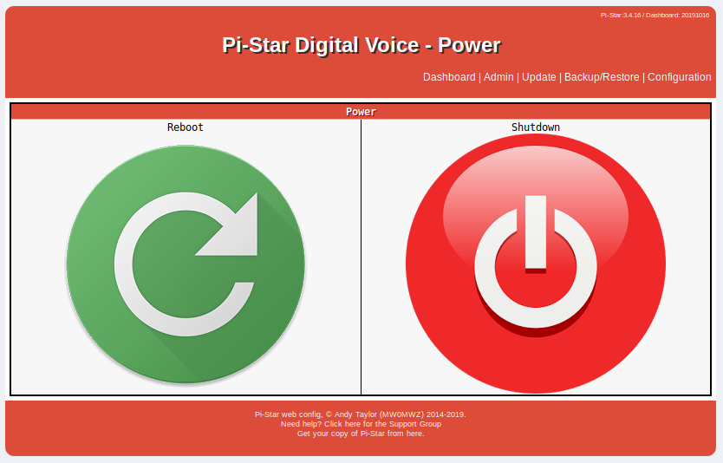

One your Jumbo Spot has started again you should see the LED fliker and after about 5minutes your LCD display will come on.

You should now be up and running.

Lets try and find your admin screen on your wifi by ether looking at your LCD display of your Jumbo Spot or using an APP on your mobile phone call Fing.
Fing APP screen

Here is where you could possibly see your IP
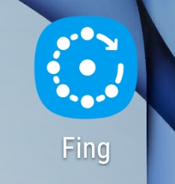

Here is the fing app that found you Jumbospot on your wifi network so you can get to its admin screen

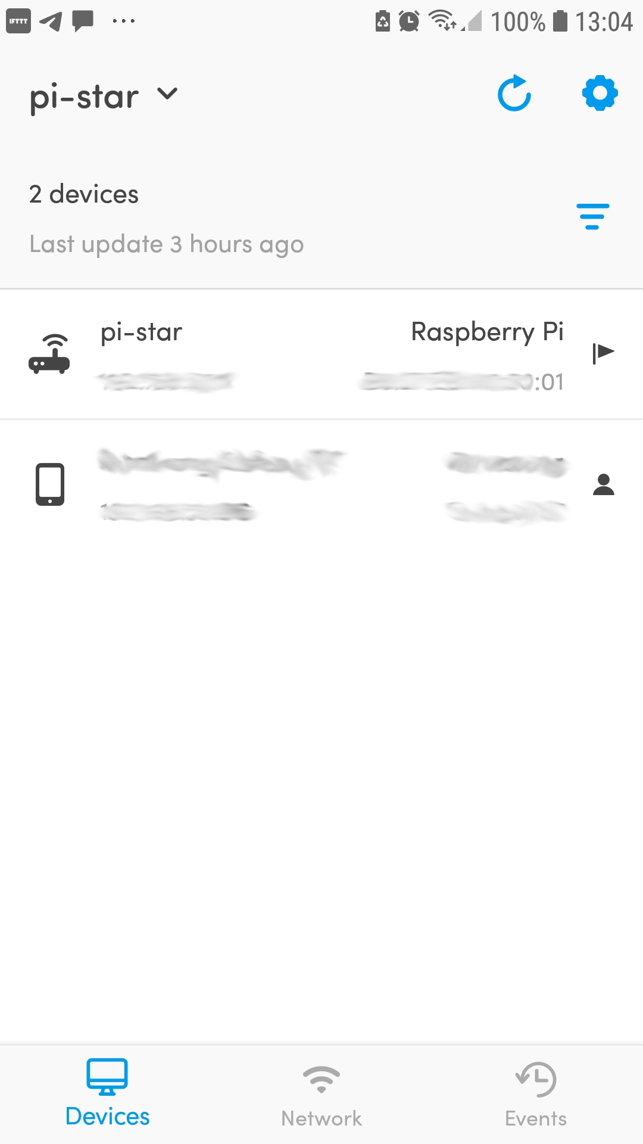

If you have predded the PTT on your DMR Mobile radio you should be able to see the IP on the Jumbospot as well.
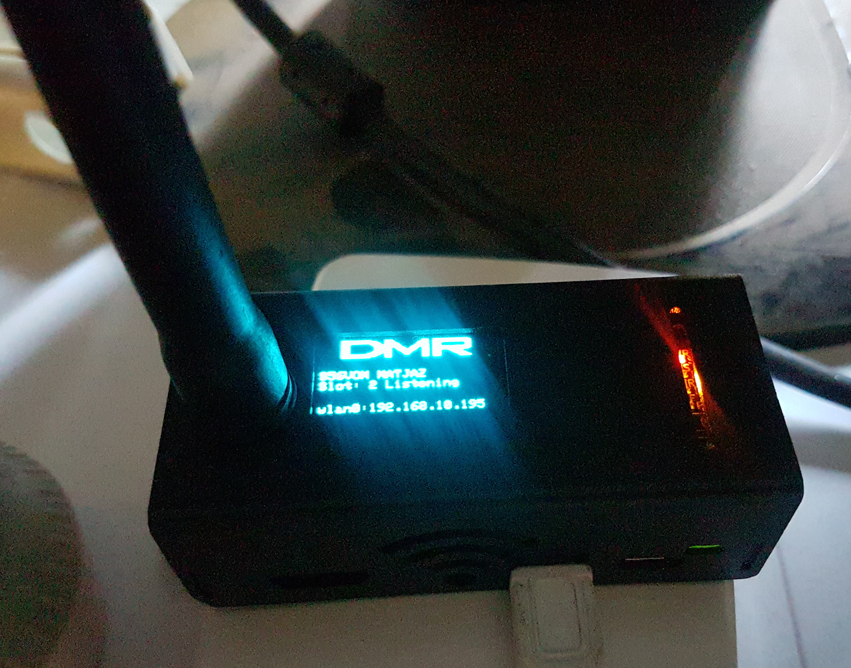
Goto a hostpot frequency on your portable DMR radio and select the relevant zone and select a talk group EG TG91 witch is international where there is lots of communication.
Key your Mobile PTT on the TG91 channel.

Got you browser and connect to your Jumbo spot Administration

http://ip_above

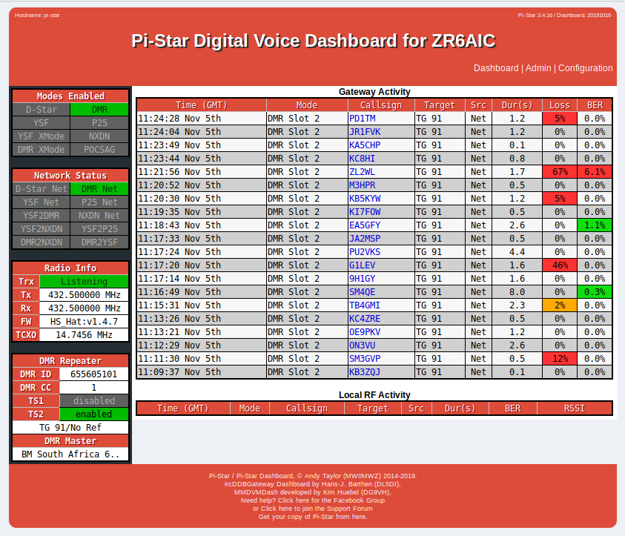

Hope you have lost of fun :-)

